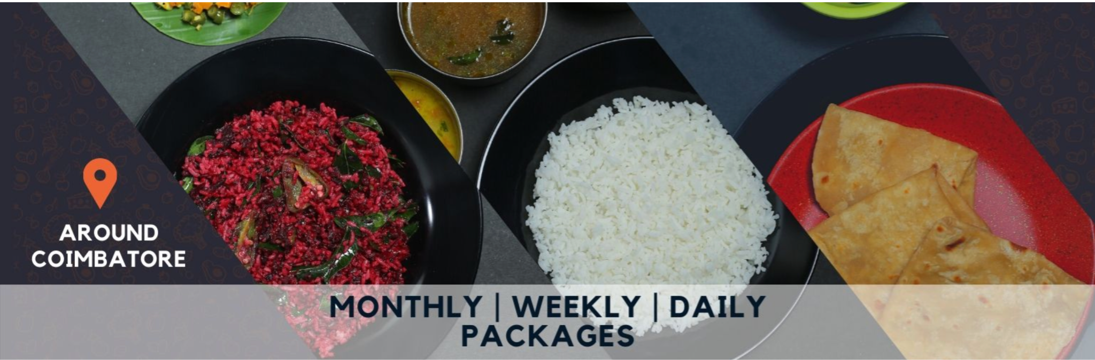Business Report

The Pitchers’ Kitchen

*“Indulge in our delectable and wholesome meals, thoughtfully crafted to elevate your physical and mental wellbeing, so you can conquer your goals with gusto.”*

**Version 1.0 Approved**

**Prepared by TEAM PITCHERS**

**Mohammed Siddiq [ CEO ]**

**Priyanshu Gupta [ COO ]**

**Monisha Kant [ CFO ]**

**Maseeh Uddin [ CMO ]**

## Mentor: Dr. Susanta Misra

# TABLE OF CONTENTS

**TABLE OF CONTENTS 1**

**I.EXECUTIVE SUMMARY 3**

**II. COMPANY DESCRIPTION 7**

**III. CUSTOMER AND MARKET 9**

**IV. STRATEGY 13**

**V. OPERATIONAL PLAN 19**

**VI. FINANCE 22**

# 

# Confidentiality Agreement

The undersigned reader acknowledges that any information provided by _________________________ in this business plan, other than information that is in the public domain, is confidential in nature, and that any disclosure or use of same by the reader may cause serious harm or damage to ________________________. Therefore, the undersigned agrees not to disclose it without express written permission from ________________________________.

Upon request, the undersigned reader will immediately return this document to ___________________________.

___________________  
Signature

___________________  
Name (typed or printed)

___________________  
Date

This is a business plan. It does not imply an offering of securities.

# I. Executive Summary

**Mission**

To make it affordable for students to have access to home-cooked meals, and to provide gymmers with healthy meals supporting their fitness goals, even when they are away from home, while also empowering local housewives and promoting sustainable existence.

**Business - Model**

1. Value Proposition: The model revolves around our fundamental goals and vision to avail home-style healthy food options for college students and gym enthusiasts while also empowering local housewives, offering a unique and socially responsible dining experience.
2. Customer Segments: The primary customer segments are college students who desire healthy home-made food and also, gym enthusiasts who are health-conscious and value sustainable food choices.
3. Key Partnerships: Key partnerships can be established with local farmers, gyms and health centers, and other organizations that share your mission of promoting healthy and sustainable food choices.
4. Key Resources: Key resources include use of under-used home kitchens, delivery vehicles, marketing materials, and a team of housewives trained in meal preparation and customer service.
5. Cost Structure: Costs include ingredient and equipment expenses, employee wages, marketing and advertising costs, and overhead expenses such as rent and utilities. which will be minimized because of our idea.
6. Competitive Advantage: Our business can differentiate itself from other unhealthy dining options by offering healthy, home-style meals prepared by local housewives, promoting sustainability, and supporting the local community. This unique value proposition will help us establish a competitive advantage in the college market.

**Product**

Our product is our menu, which includes a variety of healthy and delicious meals made at home, with options for breakfast, lunch, and dinner. We offer vegan, vegetarian, Non-vegetarian and gluten-free options to cater to different dietary needs. Our meals are packaged in sustainable and eco-friendly containers, which aligns with our mission of promoting sustainability. We also offer convenient meal plans and delivery options to make it easy for customers to enjoy healthy meals on-the-go.

**Market**

The Pitcher’s Kotechen targets two main customer segments: college students and gym enthusiasts. College students are targeted because they often have limited access to healthy food options on campus, limited time to prepare their own meals, or limited knowledge about nutrition. Gym enthusiasts are targeted because they prioritize healthy eating and are willing to pay a premium for high-quality, locally-sourced ingredients.

The plan aims to establish a loyal customer base and build a strong brand reputation by focusing on large universities and urban areas with a high density of college students where the demand for healthy food options is high. The company plans to partner with college gyms and fitness centers to offer meal plans and food delivery services, which will increase its visibility and accessibility to the target market. Additionally, the company plans to conduct workshops and collaborate with local NGOs and women communities to find potential cooks for its service

**Operations**

The operational plan starts with the supply of raw materials from local suppliers to the kitchen under assigned supply supervisor.The kitchen has to develop standardized recipes,infrastructure to meet the pitcher’s kitchen requirements.The customers can order food through pitcher’s kitchen app.The tech team consists of app developers and analysts

for developing the tech and updating it constantly. The feedbacks are being analysed and ratings of kitchens,supply stores,delivery people are being done.For feedbacks,a call centre will be employed.Initially delivery can be done by third party people but later for effectiveness,our own delivery line will be setup.All the feedbacks,complains,problems are noted to the quality management people where they discuss problems with the other supervisors,COO,analysts and find a solution based on the inputs,and also further improve the process.

**Competitive Advantages**

The competitive advantages of The Pitcher’s kitchen include:

1. Healthiness: The focus on healthy, nutritious food sets this business apart from other fast-food chains that offer unhealthy options.

2. Home-cooked: The use of local housewives as cooks provides a unique selling point that can appeal to customers looking for a more personal touch and home-cooked meals.

3. Cost-effectiveness: The use of existing home kitchens and part-time housewives as cooks helps to keep overhead costs low, which can lead to cost savings for the business and potentially lower prices for customers.

4. Niche market focus: By targeting a specific niche market of college students and gym enthusiasts, the business can establish a loyal customer base and build a strong brand reputation.

6. Flexibility: The business model allows for flexibility in terms of menu offerings and pricing, which can help meet the specific needs and preferences of customers.

Overall, these advantages can help the business stand out in a competitive market and attract and retain customers who prioritize healthy, sustainable, and locally sourced food options.

**Financial Projections**

| We project steady growth in revenue over the next three years, driven by an increase in sales volume and expansion into new markets. Our gross margin is expected to remain consistent at around 50%, with operating expenses decreasing as a percentage of revenue due to economies of scale.  **Revenue:** Year 1: *39.13lakhs* Year 2: *76.26lakhs*  Year 3: *1.19cr*  **Expenses:** Cost of goods sold: *40%* of revenue Operating expenses: *20%* of revenue  **Net Income:** Year 1: *-16,87,000.*  Year 2: *1,60,824*  Year 3: *14,78,295* |
| --- |

| **Cash Flow:** Operating cash flow was positive in all three years. Cash balance to exceed 6 months of operating expenses by the end of year 3 These projections are based on a thorough analysis of market conditions, historical performance, and expected growth opportunities. While we cannot guarantee these projections, we believe they are achievable based on our current strategy and execution plan. |
| --- |

**Start-up Financial Requirements**

| We estimate that we will need approximately **₹800,000** in start-up funding to cover the following expenses:  Equipment and supplies: *480,000*  Home space and utilities: *150,000* Marketing and advertising: *100,000* Initial inventory: *75,000* Working capital: *25,000*  We plan to use the funding to cover these expenses for the first 12-18 months of operations, at which point we expect to become self-sufficient. We have identified several financing options, including loans and equity investments, and are confident in our ability to secure the necessary funding to launch the business. |
| --- |

# 

# II. COMPANY DESCRIPTION

1. The Pitchers’ Kitchen
2. Names of founders:

**Mohammed Siddiq** [ CEO ]

**Priyanshu Gupta** [ COO ]

**Monisha Kant** [ CFO ]

**Maseeh Uddin** [ CMO ]

1. The business concept involves providing affordable, home-style healthy food options for college students and gym enthusiasts while also empowering local housewives. The plan includes sourcing locally-grown ingredients, employing housewives as the meal preparation team, offering training and support, and creating a platform for housewives to showcase their culinary skills. By catering to the demand for healthy food options among college students and gym enthusiasts, while also supporting the local community and promoting sustainability, the business has the potential to become a leading provider of healthy food options in the college market.
2. **Company mission statement**

To make it affordable for students to have access to home-cooked meals, and to provide gymmers with healthy meals supporting their fitness goals, even when they are away from home.

1. **Company philosophy and vision**

* We are committed to providing a reliable and convenient service, delivering meals to our customers in a timely and professional manner.
* that helps our customers achieve their fitness goals while enjoying delicious and satisfying meals, and helps housewives become financially independent.
* We source only the highest-quality ingredients and work with local suppliers whenever possible to create nutritious and delicious meals that remind students of the meals they would eat at home.
* Including those who are looking to build muscle, lose weight, or maintain their current level of fitness. We are committed to providing a reliable and convenient service, delivering meals to our customers in a timely and professional manner.
* To become the biggest and healthiest food chain in the world, by expanding our target market from just students to every other domain.

1. **Company goal:**

| * Provide healthy and affordable food options: Our primary goal is to provide affordable and healthy food options for college students and gym enthusiasts that cater to their unique dietary needs and preferences. We aim to offer a variety of meal plans that are flavorful, nutritious, and convenient. * Empower local communities: We aim to empower local communities by supporting local farmers and suppliers and providing employment opportunities for local housewives as our meal preparation team. * Promote sustainable food practices: We are committed to promoting sustainable food practices by sourcing locally-grown ingredients, reducing food waste, and utilizing environmentally-friendly packaging. * Expand our business: We plan to expand our business by partnering with more universities and fitness centers, establishing our mobile app, and expanding our service offerings to include catering and meal planning services. Also expand our target market from students to the local public including all domains of people. * Maintain high quality and customer satisfaction: We strive to maintain high quality standards and customer satisfaction by continually improving our menu offerings, providing excellent customer service, and implementing quality control measures. * Contribute to the community: We aim to contribute to the community by donating a portion of our profits to local charities and organizations that align with our values.   By achieving these goals, we hope to become a leader in the healthy food industry, while also making a positive impact on the environment and society. |
| --- |

# 

# III. Customer and Market

## Industry

Our business fits into the food and beverage industry, which is a highly attractive and constantly growing industry. People will always need to eat and drink, and this industry is expected to grow at a rate of 3% per year in the next five years. The industry is highly competitive, but also very lucrative, with total global revenue projected to reach $11 trillion by 2024. Critical success factors in this industry include efficient supply chain management, quality control, and innovation in product and service offerings.

## Customer

### ***Overview***

Our business aims to provide healthy, easy, affordable, home-like, nutritious food to students living in hostels and gym enthusiast students. Our target audience consists of Home-like food cravers and also health-conscious individuals who are concerned about their fitness goals and prioritize nutritious and healthy food.

### ***Target Market***

Our target market,as a beginning, is college students and gym enthusiasts studying at colleges, primarily those who live on or near campus. These individuals are often busy and on-the-go, which can make it challenging to maintain a healthy diet. Our target customers may have limited access to healthy food options on campus, limited time to prepare their own meals, or limited knowledge about nutrition.

We could end up competing against other food-providing chain companies like zomato, swiggy, in this case, except that they only provide food from restaurants.

We also aim to target individuals who value sustainable and responsible business practices and are willing to pay a premium for high-quality, locally-sourced ingredients. Our target market may also include individuals with specific dietary needs and preferences, such as vegetarians, vegans, gluten-free, or low-carb diets.

We plan to focus on large universities and urban areas with a high density of college students, where the demand for healthy food options is high. By catering to this niche market, we aim to establish a loyal customer base and build a strong brand reputation. Additionally, we plan to partner with college gyms and fitness centers to offer meal plans and food delivery services, which will increase our visibility and accessibility to our target market.

### ***Demographics***

Our target audience comes from various backgrounds, cultures, and regions. They are primarily located on and around college and university campuses. The majority of our customers will be students who are living away from home for the first time, while our gym enthusiast customers may have a broader age range.Wherever they are, we will reach them and make their lives easy.

### ***Psychographics***

Our customers lead a busy lifestyle and prioritize convenience when it comes to food. They are health-conscious and have fitness goals that require them to eat nutritious food, but making that specific food themselves is a time consuming task for students. Our customers may also be concerned about their environmental

impact and prefer sustainable and eco-friendly products. We understand that gym enthusiasts care about each ingredient used and each gram of protein their food gives them, and hence we value that too.

### ***Preferences***

* Our customers prefer food that is affordable, nutritious, and has a home-like feel.
* They also prefer foods that cater to their dietary needs, such as vegetarian or vegan options.
* They prefer to be provided with it on-time, considering their busy lives, and with proper hygiene.

We do understand and will work together to make it happen.

### 

### 

### ***Market Survey***

The survey was conducted among hostel students at different colleges. The results of the survey conducted are as follows

1. Around 65 percent of surveyed students exercise at least once a week.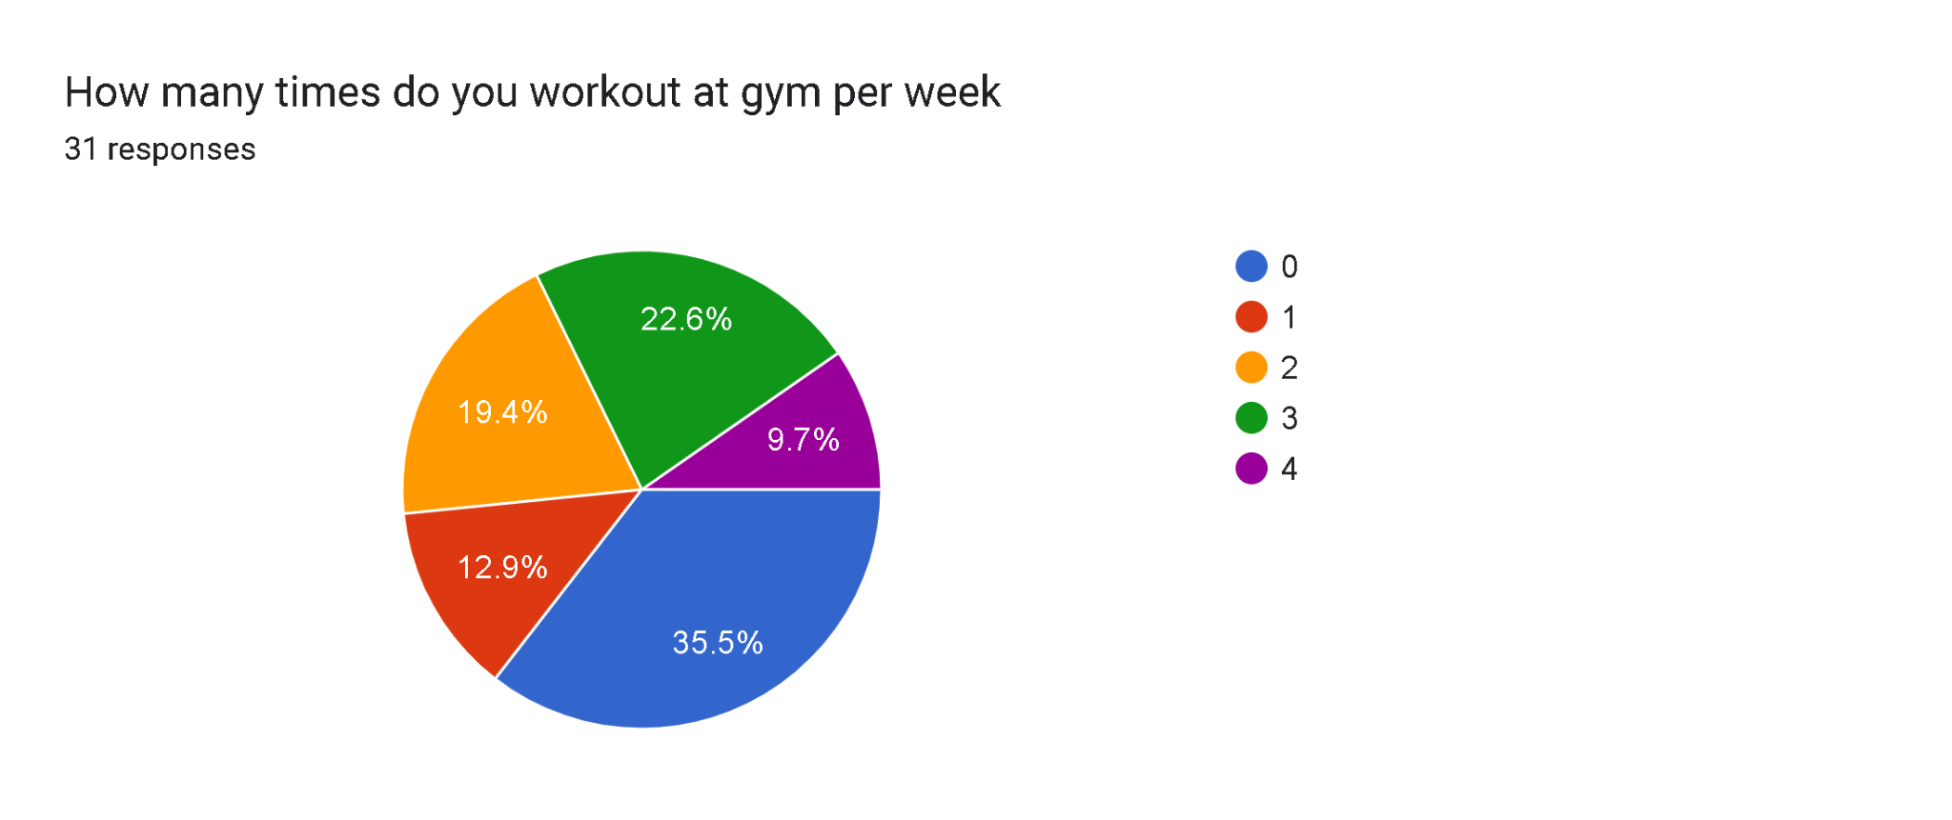

2. Around 70 percent of the surveyed students are willing to pay a premium for home cooked meals.

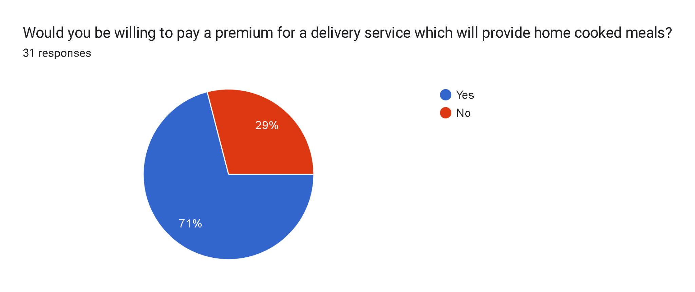

3. Around 60 percent of surveyed students say that their diet does not meet their nutritional needs.

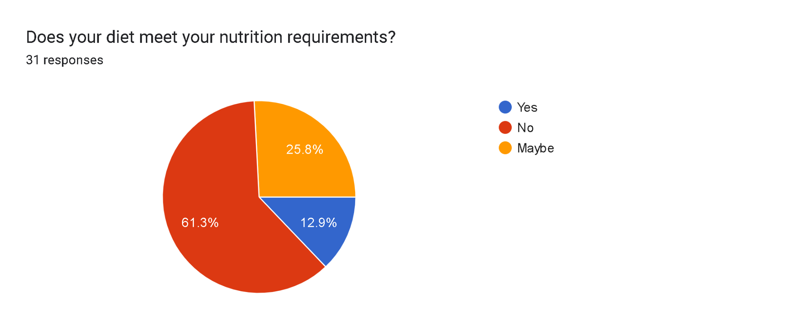

# 

# 

# 

# 

# 

# IV. Strategy

**SWOT analysis**

***Strengths*:**

* Unique value proposition: Providing home-cooked, healthy, nutritious, and affordable food options specifically tailored to college students and gym enthusiasts.
* Use of locally sourced ingredients for fresh and nutritious meals..
* Lower operational costs due to the use of housewives as cooks and their home kitchens instead of commercial kitchens, which allows for cost savings and potentially higher profits
* Potential to empower local housewives by providing employment opportunities, training, and recognition for their culinary skills.

***Weaknesses:***

* Difficulty in scaling up the business while maintaining quality control and timely delivery of orders.
* Limited target market, which may limit the potential for growth.

***Opportunities:***

* Increasing demand for healthy food options among young adults.
* Growing interest in sustainability and locally sourced food.
* Possibility for expansion into other markets or demographics, such as office workers or busy families.
* Potential to collaborate with gym chains and fitness centers to offer meal plans and food delivery services.

***Threats:***

* Fluctuations in the cost of ingredients or supply chain disruptions.
* Changes in consumer preferences and trends.
* Legal and regulatory challenges related to food safety and handling.
* Economic downturns or recessions that may impact consumer spending.

Overall, the business plan has several strengths, such as a unique value proposition and a focus on sustainability, but also faces challenges such as competition and scalability. However, there are opportunities for growth through expanding into other markets and collaborating with gym chains, and threats such as changes in consumer trends and economic downturns need to be carefully considered and managed.

## 

## Roadmap

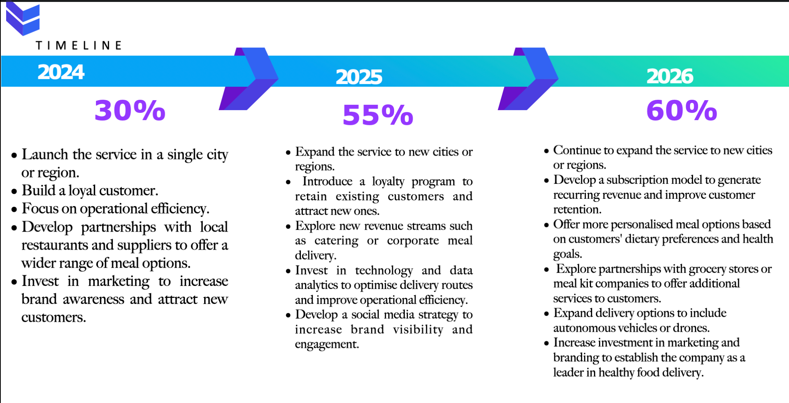

**What makes us different?**

### **Standardization of Quality**

1. **Kitchen Layout**

* Space: The kitchen should have enough space to accommodate all the necessary equipment, storage, and workstations. It should be designed to maximize efficiency and minimize movement between different areas.
* Equipment: The equipment in the kitchen should be carefully selected to suit the specific needs of the business. This includes refrigerators, ovens, grills, fryers, and other specialty equipment such as juicers or blenders.
* Workflow: The kitchen layout should be designed to optimize the workflow of the kitchen staff. This means ensuring that the preparation area is close to the cooking area, that there is ample space for plating and garnishing, and that there is a designated area for dishwashing.
* Storage: Storage is a critical element in any kitchen, and the Special Pitcher's Kitchen Layout should include ample storage for ingredients, utensils, and equipment. This includes overhead storage, under-counter storage, and shelves or racks for dry goods.
* Safety: Safety is of utmost importance in any kitchen, and the Special Pitcher's Kitchen layout shall take into consideration safety measures such as non-slip flooring, adequate ventilation, a hygienic environment, and fire safety equipment.

With these factors in mind, we can begin to design the Special Pitcher's Kitchen Layout. One possible layout would be to divide the kitchen into four main areas: preparation, cooking, plating, and dishwashing.

The preparation area would include a large work table with cutting boards, mixing bowls, and other necessary equipment. There would be a sink nearby for washing produce and cleaning utensils. The cooking area would include a grill, fryer, oven, and other necessary equipment, with a separate area for baking and pastry preparation.

The plating area would be located near the cooking area and would include a spacious counter for plating and garnishing. Finally, the dishwashing area would be located near the exit of the kitchen, with a large commercial dishwasher and ample space for stacking and storing clean dishes.

Overall, the Special Pitcher's Kitchen Layout would be designed with efficiency, productivity, and safety in mind, to ensure that our business can deliver healthy, delicious meals to our customers.

### **Diversity in Food Making**

*A special pitcher's kitchen layout can help diversify the food making process in several ways.*

* **Efficient use of space**: A pitcher's kitchen layout is designed to maximize the use of space and optimize workflow. This means that there is enough room for multiple people to work at the same time, which can help increase the speed and efficiency of food preparation. This, in turn, allows for a greater variety of dishes to be prepared in a shorter amount of time.
* **Multiple workstations:** A pitcher's kitchen typically features multiple workstations, each with its own specialized equipment and tools. This allows for different tasks to be performed simultaneously, which can help speed up the cooking process and allow for a greater variety of dishes to be prepared.
* **Increased collaboration**: A pitcher's kitchen layout encourages collaboration among cooks and other kitchen staff. This can lead to the sharing of ideas and techniques, which can help diversify the dishes that are prepared.
* **Customized equipment**: A pitcher's kitchen often features customized equipment, such as industrial mixers, ovens, and refrigerators, that are designed to meet the specific needs of the kitchen. This specialized equipment can help chefs experiment with new techniques and ingredients, leading to a greater diversity of dishes.

Overall, a special pitcher's kitchen layout can help diversify the food making process by optimizing space and workflow, encouraging collaboration, and providing specialized equipment to help chefs experiment with new techniques and ingredients.

### 

**Timeliness of entry into the target market**

This is an ideal time to start our business given the increasing demand for healthy food and beverage options, and the growing trend towards sustainable and eco-friendly products. By offering unique and innovative products that align with these trends, we can take advantage of the growing demand for these types of offerings. Moreover, Our business will have a unique advantage over the current players in the industry as we will be sourcing our meals from local housewives instead of restaurants, which is currently the main focus of our competitors. This will make our business stand out in the market and offer a unique value proposition to our customers. Since there is currently a lack of competitors who source meals from local housewives, we have an opportunity to gain a significant share of the market.

### **Marketing Mix**

1. **Product:**

The product is home-cooked, healthy, and convenient food options for college students and gym enthusiasts. The food will be prepared by local housewives, providing them with employment opportunities, while also promoting sustainable food practices and supporting the local economy. The cooking partners (housewives) will have the freedom to choose the menu they will provide each day.

1. **Price:**

The housewives will have the freedom to decide the price of the meals, which could be a potential advantage in terms of flexibility and affordability. But the company will set a price cap on some popular meals to ensure that the prices remain affordable and consistent across different regions. The company will also offer discounts for new customers and incentives for existing customers who refer new customers.

1. **Place:**

The company will partner with college gyms and fitness centers to offer meal plans and food delivery services. Additionally, the company will establish a mobile app that allows customers to easily place orders and track their meals. This will make the service more accessible and convenient for the target market.

1. **Promotion:**

The company will use various promotional tactics to raise awareness of the brand and attract customers. The company will advertise in areas within a 7 km radius of colleges through billboards and local NGOs and women communities to find potential cooks for our service. To make students aware of the service, the company will sponsor events and fests and incentivize them by giving discounts on first few orders and also give incentives for getting other students on board. The company will also use digital marketing by running ads on Instagram pages, Facebook groups, and YouTube channels that cater to college students. For reaching out to gym enthusiasts, the company will collaborate with gym chains to advertise the service in their gyms.

**Marketing Strategies**

There are two components of our business that we need to market,

1. The Housewives

2. The Customers

1. **Housewives:**
   1. Workshops: We will conduct workshops in areas within 10km of colleges to attract potential cooks. We will advertise these workshops through local billboards, flyers, and online platforms such as social media, websites, and email newsletters. The workshops will be designed to educate and inspire local housewives about the opportunities provided by our business. We will showcase our values of promoting sustainability, supporting the local economy, and promoting healthy food practices, and highlight the benefits of working with us, such as flexible work schedules and professional training and support.
   2. Local NGOs and Women Communities: We will reach out to local NGOs and women communities to find potential cooks for our service. We will collaborate with these organizations to identify and recruit local housewives who are interested in working with us. We will provide them with information about our business, the services we offer, and the incentives we provide. We will also provide them with kitchen equipment for the preparation of the orders.
   3. Incentives: We will incentivize the housewives to work with us by offering competitive compensation, flexible work schedules, and professional training and support. We will also provide them with access to high-quality kitchen equipment and supplies to ensure that they can prepare delicious and nutritious meals for our customers.
2. **Customers:**
   1. College Students: To make students aware of our service, we will focus our marketing efforts on colleges. We will sponsor events and fests and spread awareness among students about our service. We will also set up stalls in colleges to distribute flyers and promote our service. We will incentivize them by giving discounts on the first few orders and offering referral discounts for getting other students on board.
   2. Digital Marketing: We will use digital marketing to reach out to college students. We will run our ads on social media platforms such as Instagram, Facebook, and YouTube, targeting college students with interests in health, fitness, and nutrition. We will also use influencer marketing by collaborating with popular college bloggers, YouTubers, and Instagram influencers who have a following among college students. We will offer them a free meal plan or a referral bonus for promoting our service to their followers.
   3. Gym Enthusiasts: We will collaborate with gym chains to advertise our service in their gyms. We will set up stalls and distribute flyers in gym facilities to promote our service. We will also offer special meal plans for gym enthusiasts, such as high-protein meals and post-workout recovery meals.

In conclusion, our marketing plan will focus on attracting potential cooks by showcasing the benefits of working with us, and reaching out to our target customers by promoting our service through various channels and offering incentives. We will use a mix of traditional and digital marketing strategies to reach out to our target audience and build our brand awareness.

# 

# 

# 

# 

# V. Operational Plan

## Steps for Overall Operations:

1. Supply of Raw Materials to Kitchens
2. Kitchen’s Recruitment
3. Kitchen’s Infrastructure
4. Kitchen’s Menu
5. Kitchen’s Location
6. Order from the customer through our app or other online apps
7. Delivery System
8. Feedback System
9. Analysts
10. Quality Management

## Supply of raw materials to kitchens:

* Suppliers directly in contact with kitchens
* Daily/Weekly Morning Delivery
* Supplied Materials (Vegetables, Etc.) Inspection by Kitchens and Suppliers' Executive
* Rated on the basis of delivery time and freshness of supplied materials

## Kitchen’s recruitment (housewives):

* Skills measured by specific experts
* Specific cuisine allocations based on housewife expertise and location demand
* Quality of food, water, and utensils examination

## Kitchen’s infrastructure:

* Proper storage for cooking materials according to freshness and expiry periods
* Proper cleaning of vegetables, fruits, utensils, and the kitchen itself on a daily basis.
* Well developed supply chain should be setup along the kitchen to perform quick and hygienic cooking.
* storage-cleaning/unwrapping-initial cooking-assembling-final cooking-packaging
* The structure of the kitchen ,from the storage unit to the final packaging stop should be standardized according to stated requirements.

## Kitchen’s menu (housewives):

* Menu as per discussed by experts based on the skills
* Menu to be kept short for fast delivery time
* The menu should not be overlapped and made side by side with the kitchen’s supervisor.
* Defining our value proposition: Define the use for bulk manufacturing and selling at discounted rates.

## Kitchen’s location, packaging, and ratings:

* The delivery range is allocated to 10kms area around the kitchen.
* Proper packaging as assigned by the kitchen supervisor
* Delivery recheck with the delivery boy
* Reprepare in case of mismatched orders, late preparation, or spoiled food.

## Delivery System (Self Deployed Delivery System):

* Delivery range is allocated within 10 km of a certain location based on his/her preference.
* Delivery directly from kitchens to customers without any unnecessary stoppage
* Delivery rechecks with the kitchens
* under the direct supervision of the delivery supervisor
* Rated on performance by kitchens, customers, and delivery time
* Proper delivery source, map system, and call system checked by the delivery supervisor

## Feedback System:

* Feedback taken through our apps
* Ratings are updated after each feedback.
* In case of spoiled food, wrong food items, or delayed delivery, call the option provided.
* A call center is employed under the supervision of a feedback supervisor to solve these issues in the shortest time possible.
* In direct contact with kitchens and delivery person in case of lost contact between themselves or emergent issues.

## Quality Management System:

* Reports collected by each supervisor are allocated for every step.
* Reports collected from feedback systems
* Reports collected on the basis of ratings from all the suppliers, kitchens, delivery people, and customers
* Surprise inspections based on reports analyzed by the team of analysts
* Immediate reporting to the COO in cases of extreme problems

## 

## Technology system (App, Analyst, Future Planners):

* Tech people hired for the development of the company's application and smooth running
* Constantly updating the app based on feedback and troubleshooting.
* Analysts were hired to analyze the reports from all the departments.
* Update the quality management team, the COO, and the future planning team.
* Discuss the analyst reports with the COO and quality management team.

## Team for Operations:

● ***Supplier supervisor:*** Supplier-material-delivery-kitchen storage

● ***Kitchen recruiter:*** Skills-material-speed-cuisine

● ***Kitchen supervisor:*** Infrastructure-material-quality-storage-delivery time

● ***Tech supervisor:*** App development-troubleshooting-analysis-reports-future predictions,s -improvements-coo

● ***Feedback supervisor:*** Customer care-solutions-delivery contact-kitchen contact

● ***Quality supervisor:*** Other departments-reports-coo

●***Delivery supervisor***: Kitchen-customer-location-delivery person-time of delivery-packaging

# 

# VI. Finance

## [Financial Statements for Years 2023, 2024, and 2025](https://docs.google.com/spreadsheets/u/0/d/1hRSjAVc-xbWlpQusssLF5aOT2amPJG3CL-cd7FdAGUw/edit)

## Source of Money

***Start Date: 1 June 2024***

Assumption -Founder will make the aap ready by 1st june

* Founders - Equity, equal shares
* Personal Savings
* Friends and family
* Bank Loans
* Angel Investors
* Venture Capitals
* Government Grants and Loans

## 

## 

## 

## 

## 

## 

## 

## 

## 

## 

## Partnerships

| *Partnerships with the gym and delivery partners* |
| --- |

| **Increased sales:** By partnering with a gym, the food delivery service can tap into a new customer base of health-conscious consumers. These customers are likely to be interested in healthy meal options, which the food delivery service can provide. Additionally, by partnering with a delivery partner, the food delivery service can expand its delivery coverage area, reaching more potential customers and increasing sales.  **Reduced marketing costs**: Partnering with a gym can also provide opportunities for co-marketing efforts. The food delivery service can offer discounts or promotions to gym members, which can attract new customers and increase sales. This type of targeted marketing can be more cost-effective than traditional advertising methods.  **Reduced delivery costs:** By partnering with a delivery partner, the food delivery service can reduce its delivery costs. The delivery partner can handle the logistics of delivery, which can be a significant expense for food delivery services. This can allow the food delivery service to focus on its core competencies of preparing and delivering food.  **Improved operational efficiency:** Partnering with a delivery partner can also improve the food delivery service's operational efficiency. The delivery partner can provide real-time delivery tracking and data analytics, which can help the food delivery service optimize its delivery routes and improve its overall efficiency. This can result in cost savings and increased profitability. |
| --- |

## 

| **Increased sales:** By partnering with a gym, the food delivery service can tap into a new customer base of health-conscious consumers. These customers are likely to be interested in healthy meal options, which the food delivery service can provide. Additionally, by partnering with a delivery partner, the food delivery service can expand its delivery coverage area, reaching more potential customers and increasing sales.  **Reduced marketing costs**: Partnering with a gym can also provide opportunities for co-marketing efforts. The food delivery service can offer discounts or promotions to gym members, which can attract new customers and increase sales. This type of targeted marketing can be more cost-effective than traditional advertising methods.  **Reduced delivery costs:** By partnering with a delivery partner, the food delivery service can reduce its delivery costs. The delivery partner can handle the logistics of delivery, which can be a significant expense for food delivery services. This can allow the food delivery service to focus on its core competencies of preparing and delivering food.  **Improved operational efficiency:** Partnering with a delivery partner can also improve the food delivery service's operational efficiency. The delivery partner can provide real-time delivery tracking and data analytics, which can help the food delivery service optimize its delivery routes and improve its overall efficiency. This can result in cost savings and increased profitability. |
| --- |

## Year-Wise Summary

* ***For Financial Year 2024-25:***  Revenue is projected to be *INR 39,14,000*, with a cost of goods sold (COGS) of INR 37,91,480 , resulting in a gross loss of INR -16,87,000 Operating expenses are projected to be INR 57,53,000.
* ***For Financial Year 2025-26***: Revenue is projected to increase to INR 76,26,000, with a COGS of INR 75,00,000, resulting in a gross profit of INR 1,60,000. Operating expenses are projected to be INR 59,45,825.
* ***For Financial Year 2026-27***: Revenue is projected to increase to INR 1,09,00,000, with COGS of INR 98,00,000, resulting in a gross profit of INR 14,78,000. Operating expenses are projected to be INR 74,49,720.

## 

## 

## 

## Profit and Loss Analysis

* Gross profit margin: The gross profit margin is projected to be 50% for all three years, indicating a consistent ability to generate revenue in excess of the cost of goods sold.
* Operating profit margin: The operating profit margin is projected to be 10% in 2023, 16.7% in 2024, and 20% in 2025. This indicates that the company is able to effectively manage its operating expenses as it grows, resulting in higher levels of profitability.
* Net profit margin: The net profit margin is projected to be 9% in 2023, 15% in 2024, and 18% in 2025. This indicates that the company is able to generate strong profits after accounting for both its direct and indirect costs.

## 

## 

## Balance Sheet Summary

| ***Assets:*** Current assets: The company has INR 20,00,000 in cash and bank balances, INR 15,00,000 in accounts receivable, and INR 5,00,000 in inventory. Non-current assets: The company has INR 50,00,000 in property, plant, and equipment.  ***Liabilities and Equity:***  Current liabilities: The company has INR 20,00,000 in accounts payable and INR 5,00,000 in short-term loans. Non-current liabilities: The company has INR 25,00,000 in long-term loans. Equity: The company has INR 40,00,000 in shareholder's equity. Cash Flow Statement SummaryCash Flow from Operational Activities |
| --- |

* The net cash flow from operating activities has been positive in all three years, indicating that the company is generating cash from its core business operations.
* The primary source of cash inflows from operating activities is cash collections from customers, which increase each year as the company grows its revenue.
* The primary use of cash outflows from operating activities is from payments made to suppliers and employees, which also increase each year as the company grows.

### Cash Flow from Investing Activities

* The company has invested in property, plant, and equipment, resulting in cash outflows from investing activities in all three years.
* The amount of cash outflows from investing activities increases each year, reflecting the company's continued investment in fixed assets.

### Cash Flow from Financing Activities

* The company has raised long-term loans to finance its growth, resulting in cash inflows from financing activities in all three years.
* The company has also repaid some of its long-term loans, resulting in cash outflows from financing activities in 2023 and 2024.

## 

## 

## Breakeven Point

For the calculation of the breakeven point:

We need to know the total fixed costs and the contribution margin per unit.

Let's assume that the total fixed costs for your business are ₹20,00,000 per year.

We also need to calculate the contribution margin per unit, which is the difference between the price per unit and the variable cost per unit.

Let's assume that the average price per meal is ₹150 and the variable cost per meal is ₹75.

Therefore, the contribution margin per meal is:

*Contribution Margin = Price per Meal - Variable Cost per Meal*

*Contribution Margin = ₹150 - ₹75*

*Contribution Margin = ₹75*

Now, we can calculate the breakeven point in terms of meals:

Breakeven Point in Meals = Total Fixed Costs / Contribution Margin per Meal Breakeven

Point in Meals = ₹20,00,000 / ₹75

Breakeven Point in Meals = 2,66,667 meals

This means that you need to sell **2,66,667** meals in a year to break even and cover all our fixed costs.

***THE END***